4. Deadlock Management

4.1 Introduction to Deadlock
Every process needs some resources to complete its execution. However, the resource is granted in a sequential order.
- The process requests for some resource.
- OS grant the resource if it is available otherwise let the process waits.
- The process uses it and release on the completion.
A Deadlock is a situation where each of the computer process waits for a resource which is being assigned to some another process. In this situation, none of the process gets executed since the resource it needs, is held by some other process which is also waiting for some other resource to be released.
Let us assume that there are three processes P1, P2 and P3. There are three different resources R1, R2 and R3. R1 is assigned to P1, R2 is assigned to P2 and R3 is assigned to P3.
After some time, P1 demands for R2 which is being used by P2. P1 halts its execution since it can't complete without R2. P2 also demands for R3 which is being used by P3. P2 also stops its execution because it can't continue without R3. P3 also demands for R1 which is being used by P1 therefore P3 also stops its execution.
In this scenario, a cycle is being formed among the three processes. None of the process is progressing and they are all waiting. The computer becomes unresponsive since all the processes got blocked.
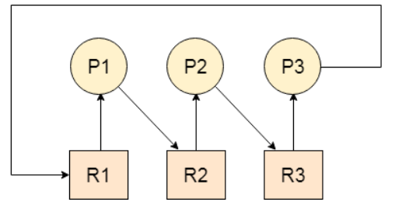

4.2 Necessary Condition of Deadlock
- Mutual Exclusion
A resource can only be shared in mutually exclusive manner. It implies, if two process cannot use the same resource at the same time.
- Hold and Wait
A process waits for some resources while holding another resource at the same time.
- No preemption
The process which once scheduled will be executed till the completion. No other process can be scheduled by the scheduler meanwhile.
- Circular Wait
All the processes must be waiting for the resources in a cyclic manner so that the last process is waiting for the resource which is being held by the first process.

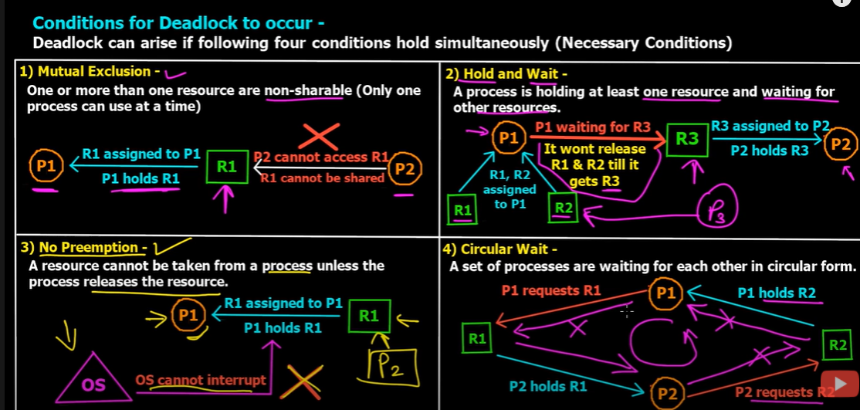

4.3 Methods for handling Deadlock
There are three approaches to deal with deadlocks.
- Deadlock Prevention
- Deadlock avoidance
- Deadlock detection

4.3.1 Deadlock Prevention
The strategy of deadlock prevention is to design the system in such a way that the possibility of deadlock is excluded. Indirect method prevent the occurrence of one of three necessary condition of deadlock i.e., mutual exclusion, no pre-emption and hold and wait. Direct method prevent the occurrence of circular wait.
Prevention techniques:
Mutual exclusion: is supported by the OS.
Hold and Wait: condition can be prevented by requiring that a process requests all its required resources at one time and blocking the process until all of its requests can be granted at a same time simultaneously. But this prevention does not yield good result because:
- long waiting time required
- in efficient use of allocated resource
- A process may not know all the required resources in advance
No pre-emption: techniques for ‘no pre-emption are’
If a process that is holding some resource, requests another resource that cannot be immediately allocated to it, the all resource currently being held are released and if necessary, request them again together with the additional resource.
If a process requests a resource that is currently held by another process, the OS may pre-empt the second process and require it to release its resources. This works only if both the processes do not have same priority.
Circular wait:
One way to ensure that this condition never hold is to impose a total ordering of all resource types and to require that each process requests resource in an increasing order of enumeration, i.e., if a process has been allocated resources of type R, then it may subsequently request only those resources of types following R in ordering.
4.3.2 Deadlock Avoidance
This approach allows the three necessary conditions of deadlock but makes judicious choices to assure that deadlock point is never reached. It allows more concurrency than prevention detection
In deadlock avoidance, the operating system checks whether the system is in safe state or in unsafe state at every step which the operating system performs. The process continues until the system is in safe state. Once the system moves to unsafe state, the OS has to backtrack one step. In simple words, The OS reviews each allocation so that the allocation doesn't cause the deadlock in the system.
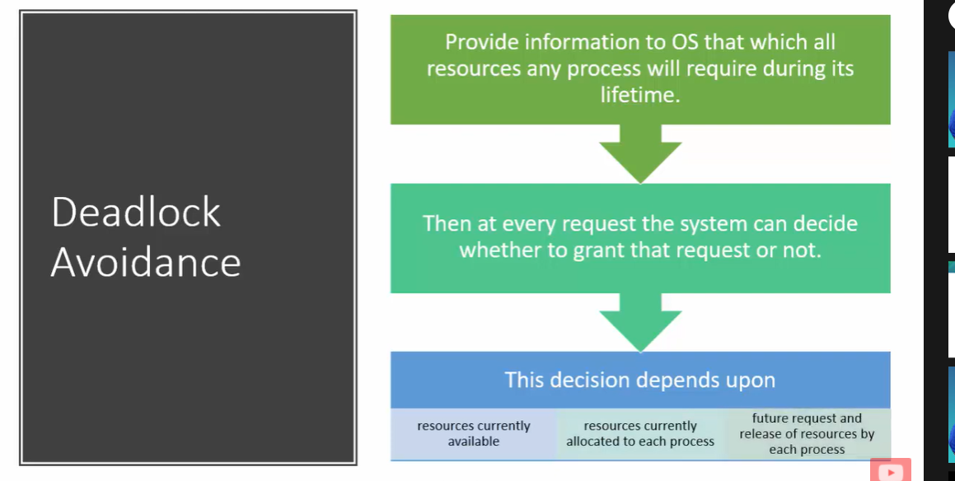
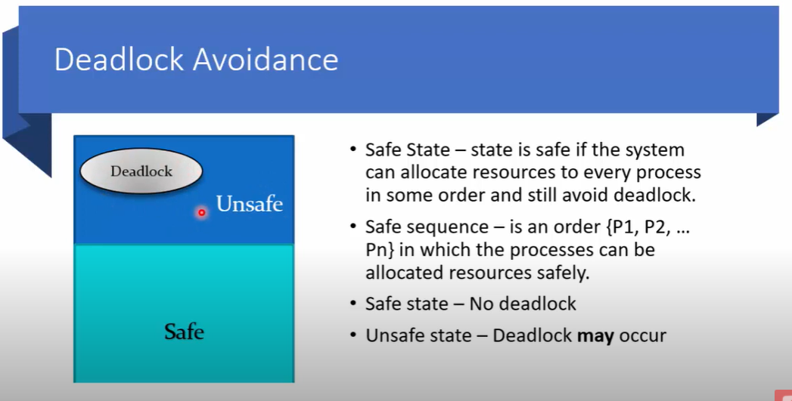

4.3.3 Deadlock detection and recovery
This approach let the processes fall in deadlock and then periodically check whether deadlock occur in the system or not. If it occurs then it applies some of the recovery methods to the system to get rid of deadlock.

